University of Malta
Faculty of ICT
Department of Computing Science

CPS1011 – Programming Principles in C

Mikhail Cassar
ID – 0319599M
Bachelor of Science (Honours) Computing Science and Mathematics

Contents

Contents
Contents 2
Task 1 – Problem Solving 4
Task 1a 4
Problem Definition 4
Code fragments 4
Output listings 5
Task 1b 7
Problem definition 7
Code fragments 7
Output listings 9
Task 1c 13
Problem definition 13
Code fragments 13
Output listings 14
Task 1d 15
Problem definition 15
Code fragments 15
Output listings 17
Task 1e 19
Problem definition 19
Code fragments 19
Output listings 21
Task 2 – Hash Tables 22
Task 2a 22
Problem Definition 22
Code fragments 22
Output listings 27
Task 2b 33
Problem Definition 33
Code fragments 33
Output listings 33
Task 2c 41
Problem Definition 41
Code fragments 41
Output listings 47
Task 2d 53
Problem Definition 53
Code fragments 53

Task 1 – Problem Solving

Task 1a

Problem Definition
“Tom invests €200 at 15% simple interest. (That is, every year, the
investment earns an interest equal to 15% of the original invest-
ment.) Joan invests €200 at 10% interest compounded annually.
(That is, interest is 10% of the current balance, including previous
addition of interest.) Write a program that finds how many years
it takes for Joan’s invested sum to overtake Tom’s along with a
display showing the two values at that time.”

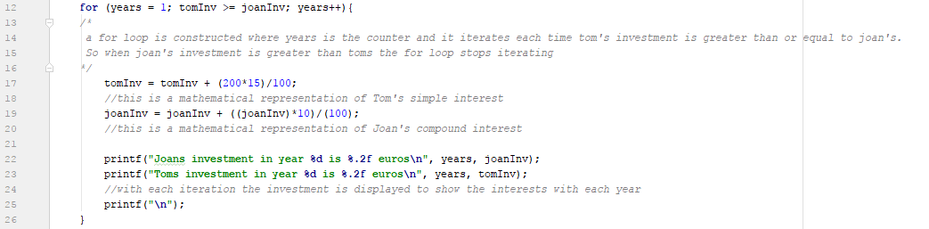
Code fragments

Figure 1: For loop of task 1a

This for loop iterates continuously as long as the value of Tom’s investment(tomInv) is less than or equal to the value of Joan’s investment(joanInv). With each iteration the value of 20% of Tom’s initial investment is added to the investment of the past year, this is simple interest. Unlike Tom, with each iteration 10% of the value of the added investment of the past year is added to the value of Joan’s investment of the past year, this is compound interest. The values of the investment of each year is printed and this stops when Joan’s investment passes Tom’s. The variable years here acts both as a counter and also keeps track of the amount of years needed for this overtaking to occur.

Output listings

Tom and Joan both start off with an equal investment of 200 euros

Joans investment in year 1 is 220.00 euros
Toms investment in year 1 is 230.00 euros

Joans investment in year 2 is 242.00 euros
Toms investment in year 2 is 260.00 euros

Joans investment in year 3 is 266.20 euros
Toms investment in year 3 is 290.00 euros

Joans investment in year 4 is 292.82 euros
Toms investment in year 4 is 320.00 euros

Joans investment in year 5 is 322.10 euros
Toms investment in year 5 is 350.00 euros

Joans investment in year 6 is 354.31 euros
Toms investment in year 6 is 380.00 euros

Joans investment in year 7 is 389.74 euros
Toms investment in year 7 is 410.00 euros

Joans investment in year 8 is 428.72 euros
Toms investment in year 8 is 440.00 euros

Joans investment in year 9 is 471.59 euros
Toms investment in year 9 is 470.00 euros

Joan's investment passes Tom's after 9 years
Tom's investment after 9 years is 470.00 euros
Joan's investment after 9 years is 471.59 euros

Process finished with exit code

This is the output of the program. The program first tells the user how much money both Tom and Joan are going to invest. Then the program outputs how much money both Tom and Joan have after each year using simple interest and compound interest respectively. This goes on until Joan’s investment exceeds that of Tom. The program then outputs how many years it takes for Tom’s investment to exceed Joan’s and also the amount of money each had when Joan’s investment passed Tom’s

Task 1b

Problem definition
“YourGreens.com sells artichokes for €2.05/kg, onions for €1.15/kg,
and carrots for €1.09/kg. It gives a 5% discount for orders of €100
or more prior to adding shipping costs. It charges €6.50 shipping
and handling for any order of 5 kg or under, €14.00 shipping and
handling for orders over 5 kg and under 20 kg, and €14.00 plus
€0.50 Eur/kg for shipments of 20 kg or more. Write a program
that repeatedly prompts users to enter the next amount of veg-
etables such that: a response of a lets the user enter the kg of
artichokes desired, b the kg of onions, c the kg of carrots, and
q allows the user to check out. The program should keep track
of cumulative totals. That is, if the user enters 4 kg of onions
and later enters 5 kg of onions, the program should report 9 kg of
onions as a single bill item.

Ultimately the program displays an itemized bill, including a break-
down of discounts and shipping costs. The program should be
written in a way so that only the final itemized bill output can be
redirected to a text file. User input validation is a requirement.”

Code fragments

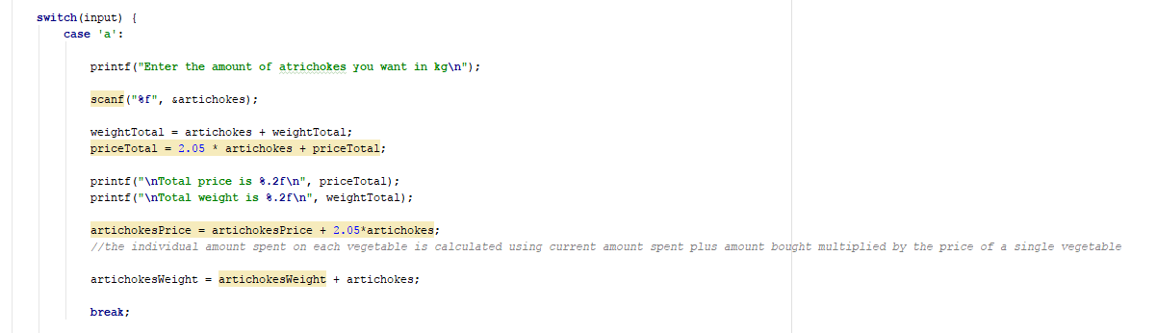
Figure 2:Switch case of menu

This function is works when the user enters a when prompted at the menu. The user here is asked the amount of artichokes he/she wants. After entering the amount of artichokes, the user wants, the total weight and total price overall is calculated. The total weight and price hold the prices and weights of all the orders made, thus including previous purchases of artichokes, onions and carrots. The individual artichoke weight and price are also calculated since the question specified for the prices and weights to be cumulative. This function is also applied to onions and carrots.

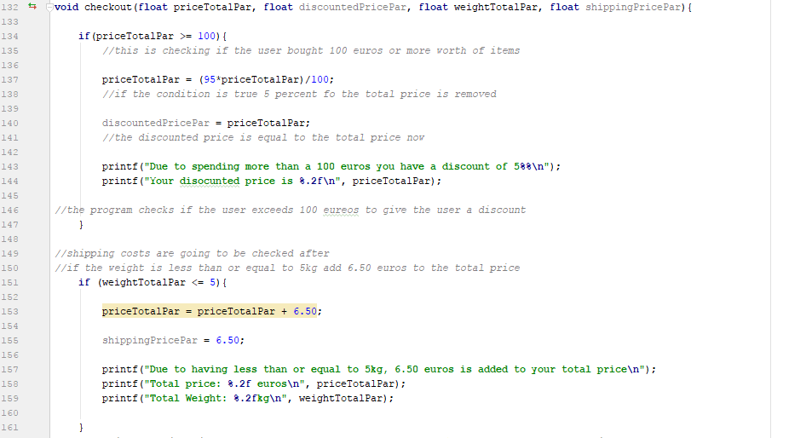
Figure 3:First part of checkout function

The first part of this function checks if the total price is greater then or equal to 100, if so a discount of 5% is given on the total price. After that the function checks the shipping cost of the order. As specified in the question, if the total weight is less than 5kg then an additional shipping price of 6.50 euros is given.
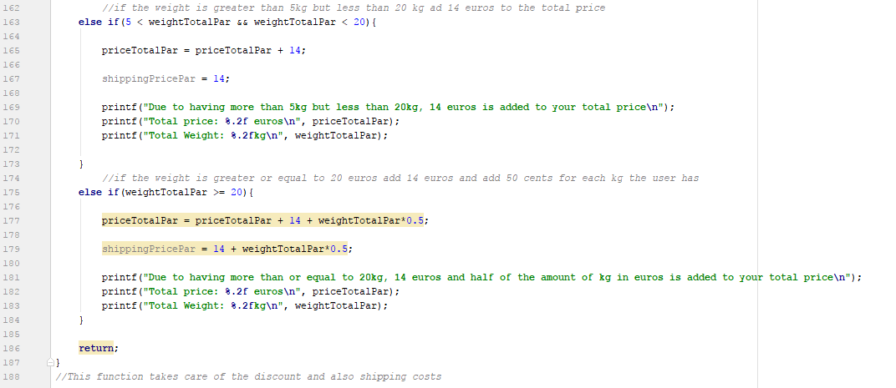

Figure 4:Second part of checkout function

if the total weight is more than 5kg but less than 20kg then an additional shipping price of 14 euros is given. If the total weight is greater than or equal to 20kg, then and addition 14 euros is added plus 50 cents for every kg the user bought.

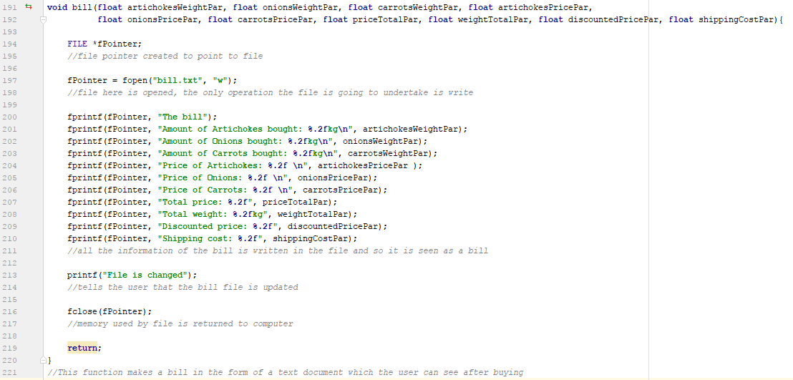
Figure 5:Bill function

This function opens a write file, so a file is created. In this file the details of the order have been given. These details are included above.

Output listings

Menu

a: artichokes (2.05/kg)

b: onions (1.15/kg)

c: carrots (1.09/kg)

q: checkout

Input:a
a
Enter the amount of atrichokes you want in kg
10
10

Total price is 20.50

Total weight is 10.00

Menu

a: artichokes (2.05/kg)

b: onions (1.15/kg)

c: carrots (1.09/kg)

q: checkout

Input:b
b
Enter the amount of onions you want in kg

15
15

Total price is 51.25

Total weight is 25.00

Menu

a: artichokes (2.05/kg)

b: onions (1.15/kg)

c: carrots (1.09/kg)

q: checkout

Input:c
c
Enter the amount of carrots you want in kg
2
2

Total price is 55.35

Total weight is 27.00

Menu

a: artichokes (2.05/kg)

b: onions (1.15/kg)

c: carrots (1.09/kg)

q: checkout

Input:1
1

Invalid Input

Menu

a: artichokes (2.05/kg)

b: onions (1.15/kg)

c: carrots (1.09/kg)

q: checkout

Input:5
5

Invalid Input

Menu

a: artichokes (2.05/kg)

b: onions (1.15/kg)

c: carrots (1.09/kg)

q: checkout

Input:a
a
Enter the amount of atrichokes you want in kg
5
5

Total price is 65.60

Total weight is 32.00

Menu

a: artichokes (2.05/kg)

b: onions (1.15/kg)

c: carrots (1.09/kg)

q: checkout

Input:q
q
Due to having more than or equal to 20kg, 14 euros and half of the amount of kg in euros is added to your total price
Total price: 95.60 euros
Total Weight: 32.00kg
File is changed
Process finished with exit code 0

bill.txt file shows:
The billAmount of Artichokes bought: 15.00kg
Amount of Onions bought: -1.#Rkg
Amount of Carrots bought: -1.#Rkg
Price of Artichokes: 30.75
Price of Onions: 30.75
Price of Carrots: 4.10
Total price: 65.60Total weight: 32.00kgDiscounted price: 0.00Shipping cost: 0.00

This output of the program shows a menu where the user inputs the requested function. The prices total up along the way and when ‘q’ is pressed the user checkout and a bill is formed in the corresponding text file.

Task 1c

Problem definition
“Write a program that reads in an input text file and differentiates
between C source files (typically include a #include directive to-
wards the beginning and are case sensitive), HTML files (typically
include the case-insensitive <html> and </html> tags towards the
beginning and end respectively), and ‘other type’ of files. The
program is permitted a margin of imprecision.”

Code fragments
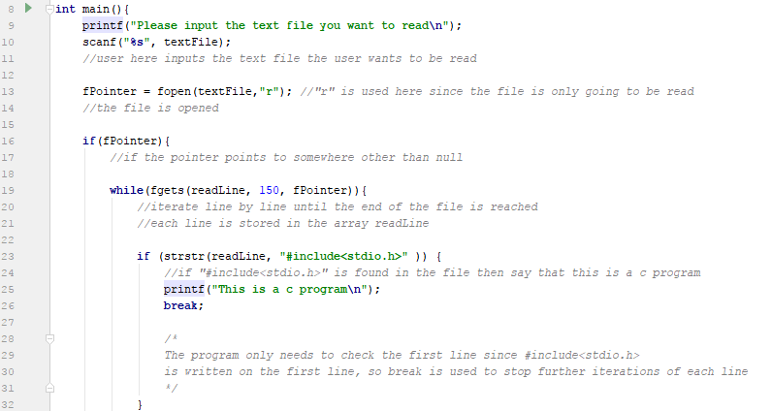

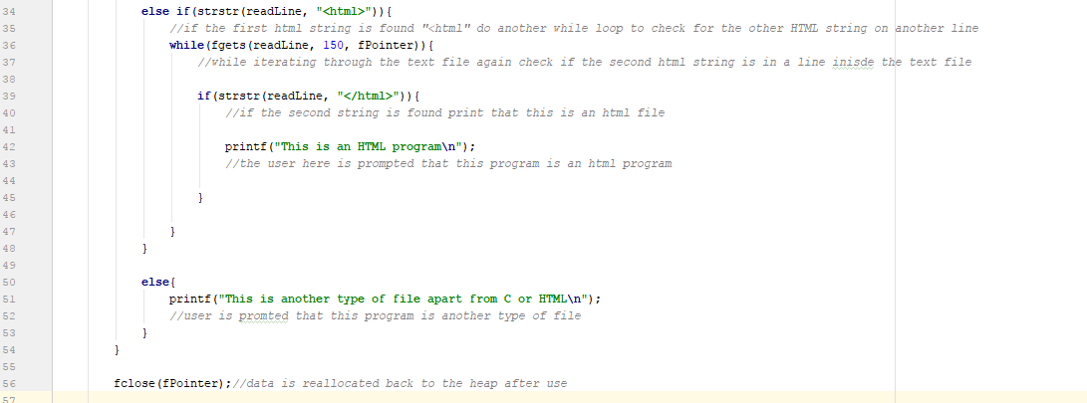
Figure 6:First part of the main function

Figure 7:Second part of main function
This program first asks a user to input the text file they want to read. Here we see that when the user enters the text file, there is a file type pointer which opens this text file and is going to read it. First the program checks if the file the user enters exists by testing the truth value using the if statement. If the file exists the line will be read line by line until EOF. With each line iteration the program checks whether this text file contains a c program, HTML file or neither. While the program is on a line, this line is checked if it contains either “#include<stdio.h>” or” <html>” and “</html>”. If the program contains the first statement in the first line then it is a c program. If the program contains both strings but one in the top while other in the end respectively, then this program is an html program. The way this was checked by first checking the first line to see if t here is the first statement, if there is check the whole program again to try and find it at the end. If both if statements are false then the program tells the user that this type of text file is something else.

Output listings

Please input the text file you want to read
file.txt
file.txt
This is a c program

File.txt:
#include<stdio.h>

Please input the text file you want to read
file.txt
file.txt
This is an HTML program
Process finished with exit code 0

File.txt:
<html>
string
string
</html>

The program here tells the user whether the file is HTML or C or if it is something else, when the input is inserted the program just gives the user a quick answer.

Task 1d

Problem definition
“Write a program that reads an input text file, identifying and
auto-correcting the following common typing errors: ‘Space before
comma or a full-stop’, ‘Multiple spaces as opposed to a single
space’, and ‘Missing spaces’. Detection of the last typo makes
use of the heuristic that ‘words longer than 12 characters and not
including a hyphen (-) are rare’. The user must be prompted to
confirm auto-correction just in these cases”

Code fragments
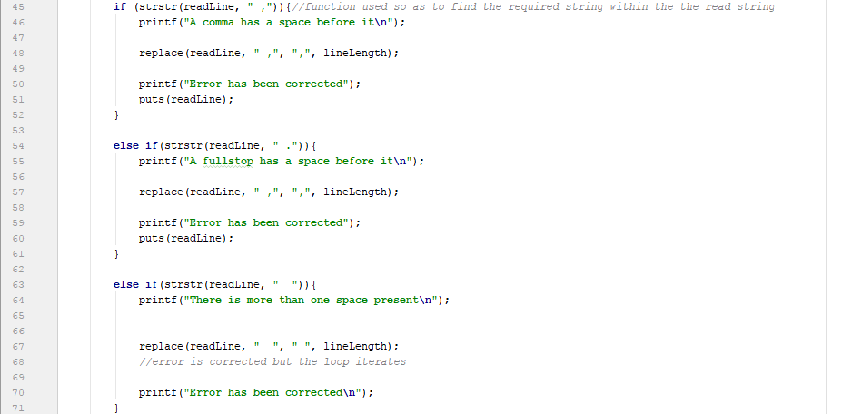
Figure 8:The conditional part of the program

This conditional statement is used to see which words have a space and a comma/full stop/space. First the line is read by the file pointer, after that the line which is put in readLine is compared with the three errors, if an error comes up the replace function is used to arrange it.

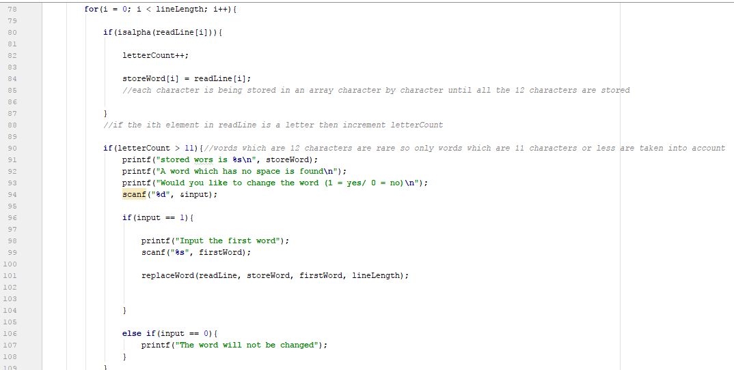
Figure 9: The second part of the conditional used to test for words without spaces

After the conditional branch, the sentence is looped through checking whether it has twelve characters without any spaces. With every iteration the character in the i’th position is checked whether it is a letter, if it is increment the counter and place the letter in a character array.
If the counter reaches a value greater than 11 then the user is told that the word has no space and if the user would like to change that or not. If yes the user is told to input a the word he would like to replace the word without spaces with, using the replaceWord() method, the word is changed. However, if the user does not change the word then the program will just output a print statement.
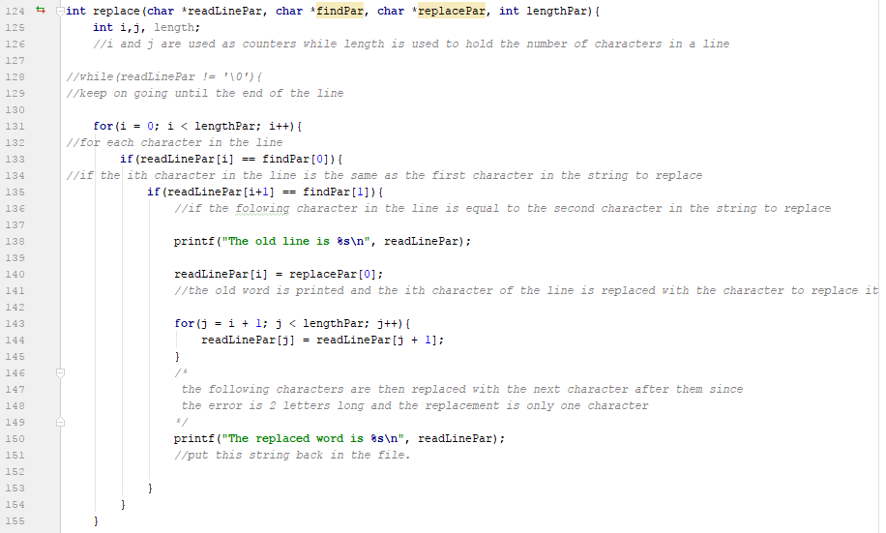
Figure 10: The repalce fucntion

A for loop is used first to iterate between all the characters in the string, if a character is equal to the first character of the string to be found and the following character is equal to the second character of the string to be fount then replace the i’th character in the line with the first character of the string to replace with.
A for loop is then used to change each character following the one that was change first.
Figure 10: The replaceWord function

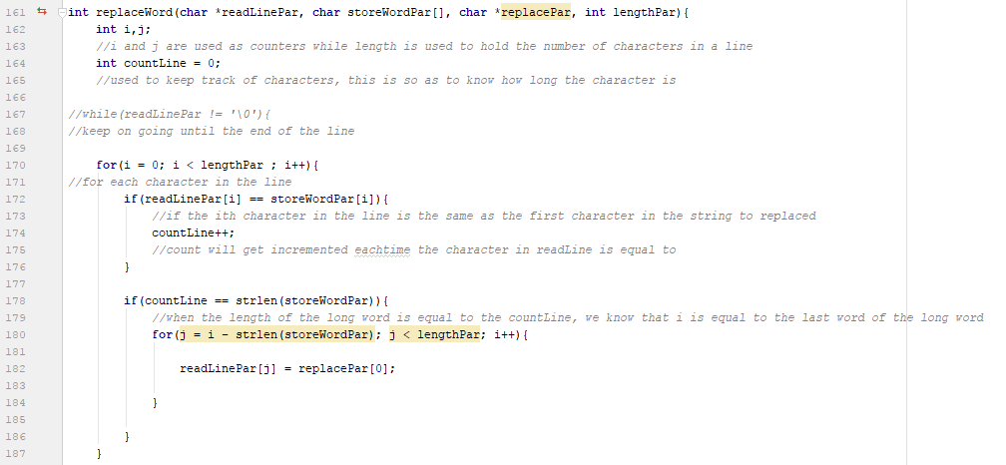

A for loop is first set up to go through each character of the line. If the i’th character in the line is equal to the i’th character which is stored then increment the counter. If the counter is equal to the length of the stored word then a for loop is created which goes makes the first character of the long word get replaced with the characters of the word to replace with.

Output listings

This program will arrange any typing errors the user has

Please input the text file you want to read
file.txt
Current line:my name is ,

A comma has a space before it
The old line is my name is ,

The replaced word is my name is,

Error has been correctedmy name is,

File.txt:
my name is ,

This program will arrange any typing errors the user has

Please input the text file you want to read
file.txt
Current line:This is try .

A fullstop has a space before it
Error has been correctedThis is try .

Current line:There are ,

A comma has a space before it
The old line is There are ,

The replaced word is There are,

Error has been correctedThere are,

Current line:mist akes

There is more than one space present
The old line is mist akes

The replaced word is mist akes

Error has been corrected
Current line:a c ,program.

A comma has a space before it
The old line is a c ,program.

The replaced word is a c,program.

Error has been correcteda c,program.

File.txt:
This is try .
There are ,
mist akes
a c ,program.

The user first inputs text into the text file, if an error found the program arranges the error and shows them the corrected version on the screen.

Task 1e

Problem definition
“Write a program that includes a memory introspection function View_stack_frame(), printing out the stack frame of caller func- tions. For simplicity’s sake, you may assume that all variables inside the callers’ stack frames are all of the same type, although their number may vary. The function displays output organized in two columns, the first displaying addresses of variables while the second displays their corresponding values. Symbolic identifier do not feature.”

Code fragments
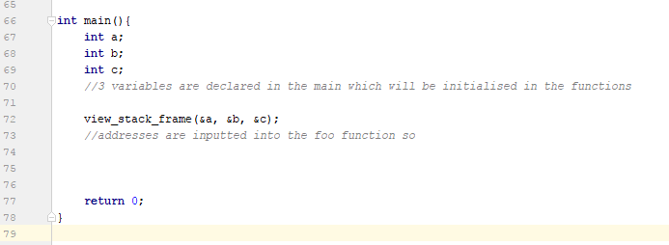
Figure 11:first part of view Stach Fram
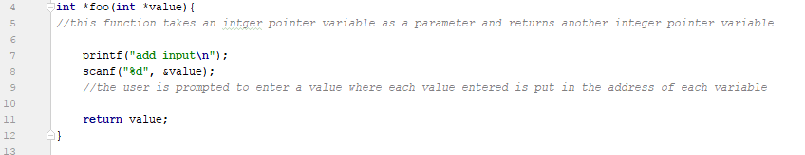
This is the main of the program, here three variables are declared and the address of each variable is passed in a function view_stack_frame
Figure 12:Function foo

This function prompts the user to enter a value, this value Is passed through different functuion until it ends up in the stack table.
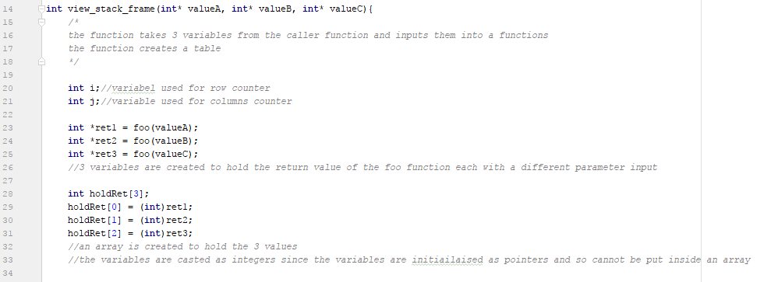
Figure 13:: view_stack_fram function part 1
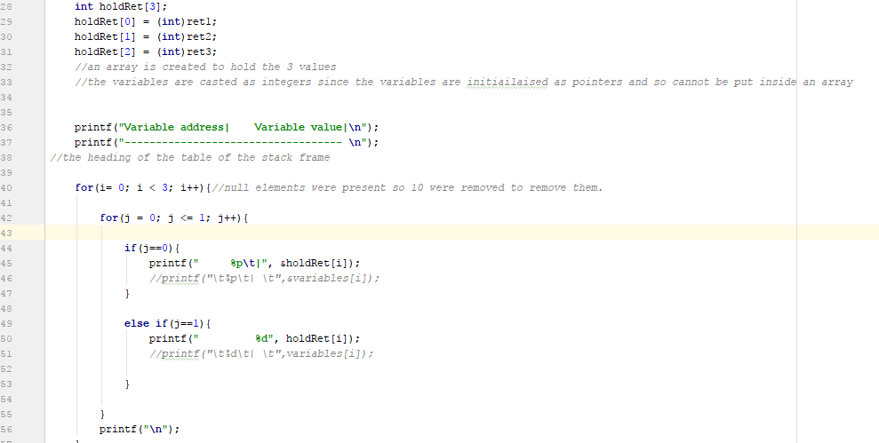
Figure 14: view_stack_frame part 2
This function holds the function foo and so memory location switched happen in between this function and foo and this function and main. Finally, a table is shown, the table is split into two columns, a column for the address and another for the variable value. The function foo returns a value, in view_stack_frame an int variables is made to hold the return value of foo. The return values are then stored in an array and the array is used to make the table.

Output listings

"C:\Users\Owner\Dropbox\Uni\Programming principles in C-CPS1011\AssignmentC\cmake-build-debug\AssignmentC.exe"
add input
1
1
add input
2
2
add input
3
3
Variable address| Variable value|
-----------------------------------
000000000060FDE0 | 1
000000000060FDE4 | 2
000000000060FDE8 | 3

Process finished with exit code 0

Here the user just needed to input 3 numbers, after doing this a table is formed. This table has to columns where one contains the address while the other contains the value of the variable.

Task 2 – Hash Tables

Task 2a

Problem Definition
“A fixed 2D array version, where the number of rows is equal to the hash space, while columns cater for key-value pair storage. In this case the hash space is pre-fixed, as well as the maximum possible number of possible collisions.”

Code fragments
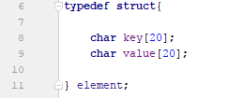
Figure 15:The structure defined in the program

This part of the program defined an element of the hash table, so each element in the hash table will point to a key and a value.
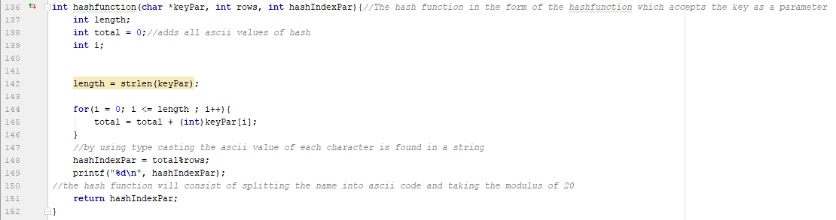
Figure 16:The hash function used in the program

This function is the function which produces an index from a given key. The key here is keyPar, this parameteris the inputted key. The function first has 3 parameters which are the key, the number of rows rows and the variable where the index will be stored hashIndexPar. Three variables are declared in the function, first is length, which holds the length of the key, second is total which holds the ascii value of each character in a word, thus having a unique value for each word. Lastly there is i which is the counter for the loop.
After initializing length, a for loop is created which loops through each character in the given key and the ascii value of each character is added to total and so the string key is mapped to numerical value. The total value obtained is moded by the number of rows in the hash table, this is done so as to obtain a value which is in the range of the number of rows. The value is set equal to the index and so the key entered is mapped on to a numerical index in the hash table. The hash index is returned from the function.

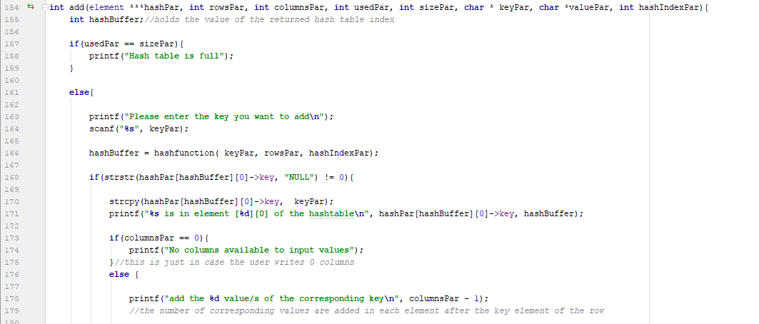
Figure 17: The add function

This function adds an element to the hash table. First the function checks if the hash table is full, this is done by keeping account of the total size of the hash table in variable size and keeping track of how many elements are used by using variable used. If both variables are equal the program tells the user that the hash table is full.
However, if there is space in the hash table, the program prompts the user to enter the desired key. The hash index is stored in variable hashBuffer. It is first checked if the first element of the row which is in the obtained index is null, if it is null then the key is added to this element and the corresponding values which are dependent on how many columns the hash table has.
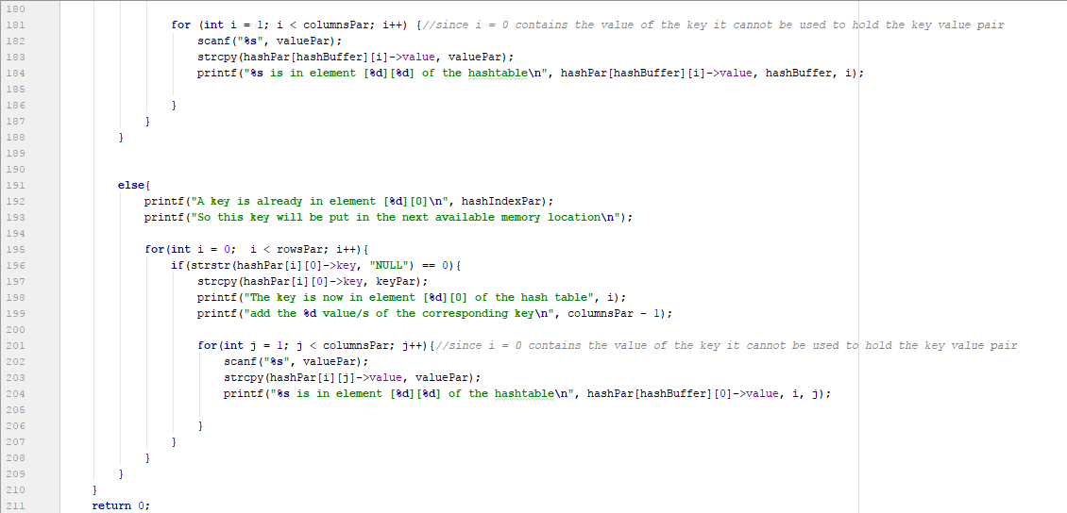
Figure 18: Second part of the add function

The user enters each value one after the other until each column in the row is full up. The program tells the user in which element is the value entered is in. If however the index obtained is already full then the program goes round each row and checks whether there is an empty first element, if there is, then the process of adding the keys and values is repeated inside the empty row.

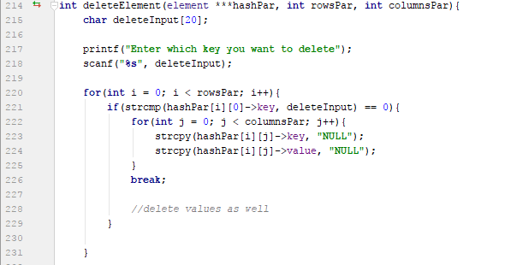
Figure 19: Delete function

This function takes three parameters, the hash table itself, the number of rows and the number of columns. A variable is initialised in the beginning which holds the key to be deleted. The user is prompted to enter the key which is to be deleted. The program goes through each key in the table, if there is a key which matches that of the key to be deleted then a the keys and values of element which contains the key is set to null. After this break is used to stop further iterations, and so only one element can be deleted at the same time which has the same key.
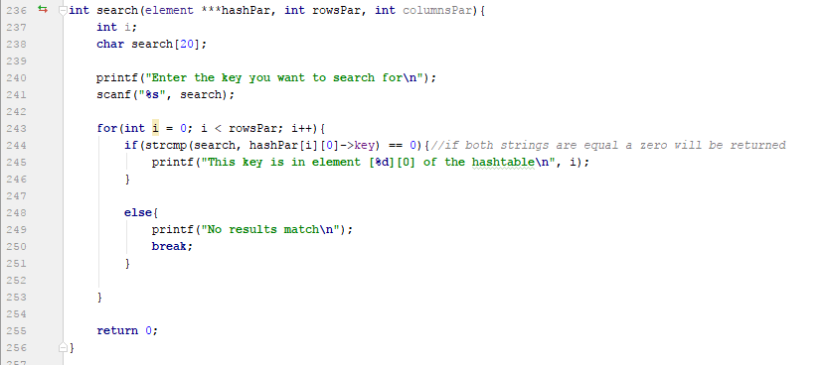
Figure 20: The search function
This function works similarly to delete however an array search is used instead of delete. When the search key is the same as the row key during iteration the location of the key is displayed along with the program saying that the key is in the hash table. If the search and rows are not equal then the user is told that the key is not in the hash table.

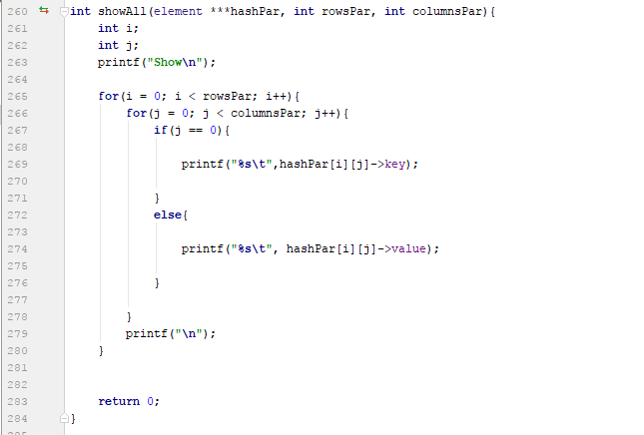
Figure 21: Show all function
This function is used to show all the elements in the hash table, this is done by having the hash table as a parameter as well as the number of rows and columns. Two counters are declared i and j, a loop and a nested loop are created so as to cycle through each element of the hash table. First, we have a value for the row and then we go through each corresponding value of that row. The entire row is printed and after that a line is skipped and the following row is then printed with the key always being in position 0.
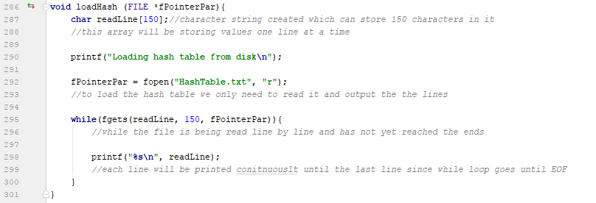
Figure 22: Load function

This function prints the previously saved text file containing the keys and values. This function takes a File pointer parameter and declares a string readLine to hold the current line. The file is then opened to be read. A while loop is used to iterate through each line until the EOF is reached. During iteration the line is printed.

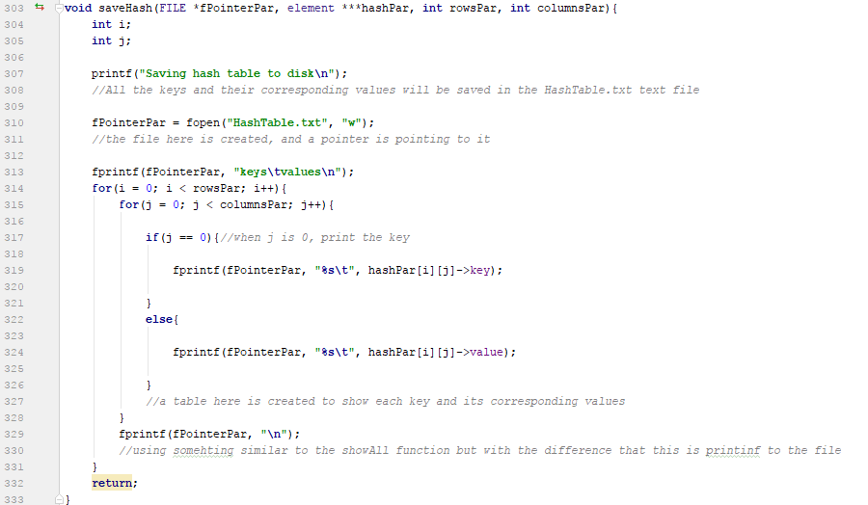

Figure 23:Function used to save

This function saves the added keys and values into a text file. Basically this function works like the showAll() function but with the difference that the keys and values are printed in a text file. When the user closes the program the text file used, in this case HashTable.txt is created if it wasn’t there before and it would have all the keys and values inputted in the table. The function fprintf() is used here instead of printf() since we are printing to a text file not on the screen to the user. This the biggest difference from the code seen in the showAll() function.
This hash table is very similar to that of 2b so less creativity was needed to construct this hash table, I made another table which is available with the other programs which basically uses a 2d-array without structures to build the hash table, it works a bit differently and deviates from the method used for the hash table of 2b.
When the user enters two keys which give the same index a collision will occur. This hash table tries to minimise collisions by taking the collided key to an empty element in the hash table, however, when there is no more free elements in the hash table only collisions will occur and so the maximum number of collisions is when a new key is trying to be added to the hash table.

Output listings

"C:\Users\Owner\Dropbox\Uni\Programming principles in C-CPS1011\untitled2\cmake-build-debug\untitled2.exe"
Enter the amount of rows you want initially
2
2

Enter the amount of columns you want initially
2
2

A table of 2 rows and 2 columns will be built

area of hash table is 4

Menu

1. add
2. delete
3. search
4. show all
5. load
6. save
7. exit

input the function you want to do
1
1
Please enter the key you want to add
Mikhail
Mikhail
1
Mikhail is in element [1][0] of the hashtable
add the 1 value/s of the corresponding key
Cassar
Cassar
Cassar is in element [1][1] of the hashtable

Menu
1. add
2. delete
3. search
4. show all
5. load
6. save
7. exit

input the function you want to do
1
1
Please enter the key you want to add
Marzia
Marzia
0
Marzia is in element [0][0] of the hashtable
add the 1 value/s of the corresponding key
Busuttil
Busuttil
Busuttil is in element [0][1] of the hashtable

Menu
1. add
2. delete
3. search
4. show all
5. load
6. save
7. exit

input the function you want to do
4
4
Show
Marzia Busuttil
Mikhail Cassar

Menu
1. add
2. delete
3. search
4. show all
5. load
6. save
7. exit

input the function you want to do
2
2
Enter which key you want to deleteMikhail
Mikhail

Menu
1. add
2. delete
3. search
4. show all
5. load
6. save
7. exit

input the function you want to do
4
4
Show
Marzia Busuttil
NULL NULL

Menu
1. add
2. delete
3. search
4. show all
5. load
6. save
7. exit

input the function you want to do
6
6
Saving hash table to disk

Menu
1. add
2. delete
3. search
4. show all
5. load
6. save
7. exit

input the function you want to do
5
5
Loading hash table from disk

Menu
1. add
2. delete
3. search
4. show all
5. load
6. save
7. exit

input the function you want to do
1
1
Hash table is full
Menu
1. add
2. delete
3. search
4. show all
5. load
6. save
7. exit

input the function you want to do
4
4
Show
Marzia Busuttil
NULL NULL

Menu
1. add
2. delete
3. search
4. show all
5. load
6. save
7. exit

input the function you want to do
1
1
Please enter the key you want to add
Kevin
Kevin
1
Kevin is in element [1][0] of the hashtable
add the 1 value/s of the corresponding key
Dimech
Dimech
Dimech is in element [1][1] of the hashtable

Menu
1. add
2. delete
3. search
4. show all
5. load
6. save
7. exit

input the function you want to do
6
6
Saving hash table to disk

Menu
1. add
2. delete
3. search
4. show all
5. load
6. save
7. exit

input the function you want to do
7
7
End of program
Process finished with exit code 0

Task 2b

Problem Definition
“A dynamic 2D array version of the above, where this time the
hash space is fully parameterizable and the number of collisions is
solely bounded by program memory availability”

Code fragments
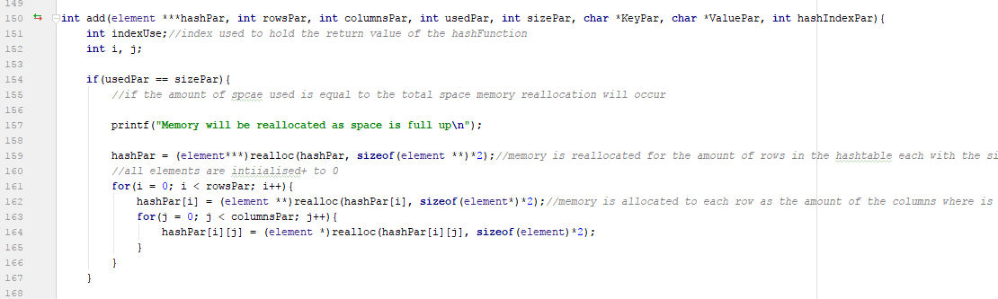
Figure 24: Used to reallocate memory in hash table
The biggest difference between 2a and 2b is this piece of code, this basically makes the hash table in 2b dynamic. During the add function in 2b when the size variable is equal to the used variable, the user that the hash table is full. However, here when the hash table is full the size is doubled and so more space is formed using memory reallocation. This hash table is only limited by the memory of the computer itself and so this is a dynamic hash table.
This hash table does all the functions the hash table in 2a does in almost exactly the same way. They both have the same functions.
Regarding collisions the maximum amount of space in the hash table is the amount of memory available by the computer, so collisions will occur when the memory is full, thus there is an undefined number of collisions.

Output listings
"C:\Users\Owner\Dropbox\Uni\Programming principles in C-CPS1011\untitled2\cmake-build-debug\untitled2.exe"
Enter the amount of rows you want initially
2
2

Enter the amount of columns you want initially
2
2

A table of 2 rows and 2 columns will be built

area of hash table is 4

Menu
1. add
2. delete
3. search
4. show all
5. load
6. save
5. exit

input the function you want to do
1
1
Please enter the key you want to add
Mikhail
Mikhail
1
Mikhail is in element [1][0] of the hashtable
add the 1 value/s of the corresponding key
Cassar
Cassar
Cassar is in element [1][1] of the hashtable

Menu
1. add
2. delete
3. search
4. show all
5. load
6. save
5. exit

input the function you want to do

1
1
Please enter the key you want to add
Ryan
Ryan
0
Ryan is in element [0][0] of the hashtable
add the 1 value/s of the corresponding key
Vella
Vella
Vella is in element [0][1] of the hashtable

Menu
1. add
2. delete
3. search
4. show all
5. load
6. save
5. exit

input the function you want to do
1
1
Memory will be reallocated as space is full up

Menu
1. add
2. delete
3. search
4. show all
5. load
6. save
5. exit

input the function you want to do
Joe
Joe
Please enter the key you want to add
0
A key is already in element [0][0]
So this key will be put in the next available memory location
The key is now in element [0][0] of the hash tableadd the 1 value/s of the corresponding key
Caruana
Caruana
NULL is in element [0][1] of the hashtable
The key is now in element [1][0] of the hash tableadd the 1 value/s of the corresponding key
bondin
bondin
NULL is in element [1][1] of the hashtable

Menu
1. add
2. delete
3. search
4. show all
5. load
6. save
5. exit

input the function you want to do
4
4
Joe Caruana
Joe bondin

Menu
1. add
2. delete
3. search
4. show all
5. load
6. save
5. exit

input the function you want to do
1
1
Please enter the key you want to add
Luke
Luke
1
A key is already in element [1][0]
So this key will be put in the next available memory location
The key is now in element [0][0] of the hash tableadd the 1 value/s of the corresponding key
Caruana
Caruana
NULL is in element [0][1] of the hashtable
The key is now in element [1][0] of the hash tableadd the 1 value/s of the corresponding key
Dimech
Dimech
NULL is in element [1][1] of the hashtable

Menu
1. add
2. delete
3. search
4. show all
5. load
6. save
5. exit

input the function you want to do
4
4
Luke Caruana
Luke Dimech

Menu
1. add
2. delete
3. search
4. show all
5. load
6. save
5. exit

input the function you want to do
5
5
Loading hash table from disk
keys values

Marzia Busuttil

Kevin Dimech

Menu
1. add
2. delete
3. search
4. show all
5. load
6. save
5. exit

input the function you want to do
2
2
Enter which key you want to deleteLuk
Luk

Menu
1. add
2. delete
3. search
4. show all
5. load
6. save
5. exit

input the function you want to do
2
2
Enter which key you want to deleteLuke
Luke

Menu
1. add
2. delete
3. search
4. show all
5. load
6. save
5. exit

input the function you want to do
4
4
NULL NULL
Luke Dimech

Menu
1. add
2. delete
3. search
4. show all
5. load
6. save
5. exit

input the function you want to do
6
6
Saving hash table to disk

Menu
1. add
2. delete
3. search
4. show all
5. load
6. save
5. exit

input the function you want to do
7
7
Exit
Process finished with exit code 0

HashTable.txt:
keys values
NULL NULL
Luke Dimech

Task 2c

Problem Definition
“The final linked list version exactly as depicted in Figure 1”

Code fragments
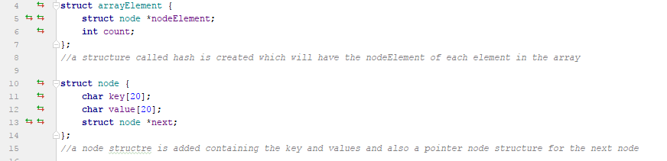

Figure 25: The structures of the hash table

These are the two structures which are used during this program. First a node structure is created which holds the key, value and pointer to the next node while then the arrayElement was created which basically holds the first node of each element in the array.
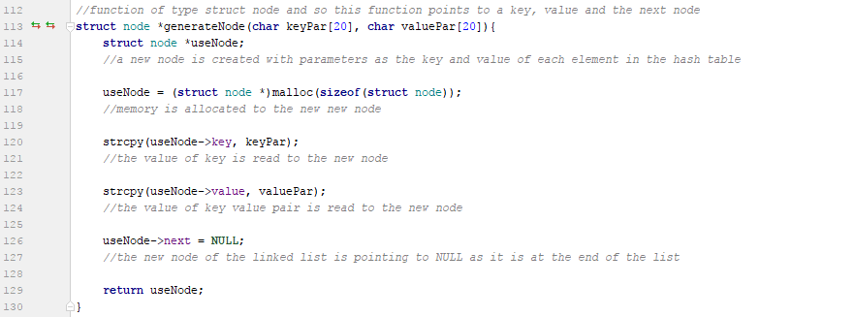

Figure 26: Function generateNode:

This function is used to create a node which will have the keys and values as given as parameters. First a node is created, then memory is allocated to it. After memory allocation the key and value given as parameters are set as the key and value pointed to by the newly created node. The node points to null since it is still new. The node has a key and value, is pointing to nothing and is pointed to by nothing.

Figure 27: InsertElement function part 1
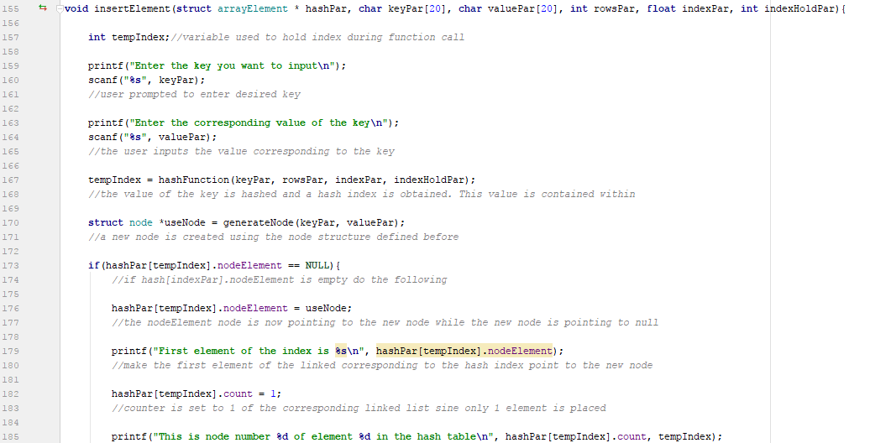

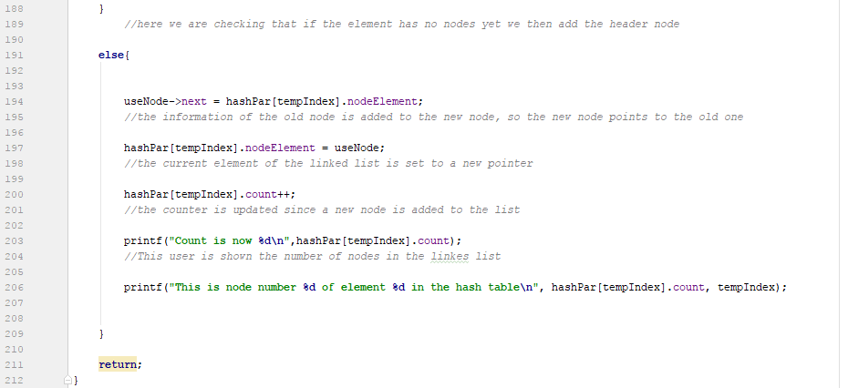

Figure 28:InsertElement function part 2

This function adds a node to the indexed element in the hash table. First the user is prompted to enter the key and value and then the index is calculated using the hashFunction() method and is stored in the tempIndex variable. Then a new node is created with the entered key and value passed as parameters. Then the function checks if the element at the index contains a header node or not, if the element contains no header node then it will create one. The element at the index is made to point to the newly created node and so that node is the first element at that index. If the header is not empty the new node is made to point to the old node. The current element of the linkes list is set to point to the new node. The counter increases, this keeps track of the number of nodes in an index.

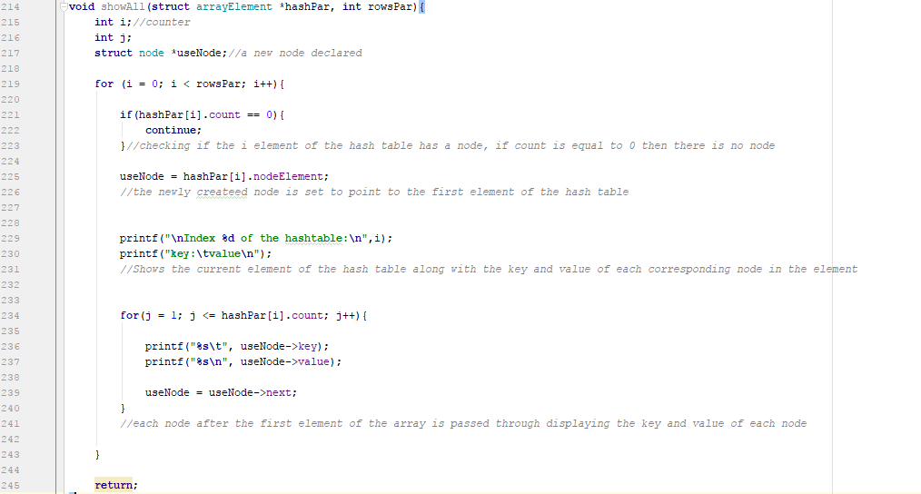

Figure 29: showAll function
This function outputs all the keys and values in each node of at each index. A for loop is created first which iterates through each index of the hash table, the counter of each at each index is checked, if the counter is 0 it means that there is no nodes at this index so iterate again. After finding an index which has nodes, the information of the first node is put into a new node and another for loop is created to go through each node in an index. The for loop starts at 1 and goes till the value of count since the number of nodes is stored there. The key and value of each node is printed and the new node is set to point to the following node so with each iteration the node points to the following iteratively. This is done until all keys and values of each node of each index is printed.

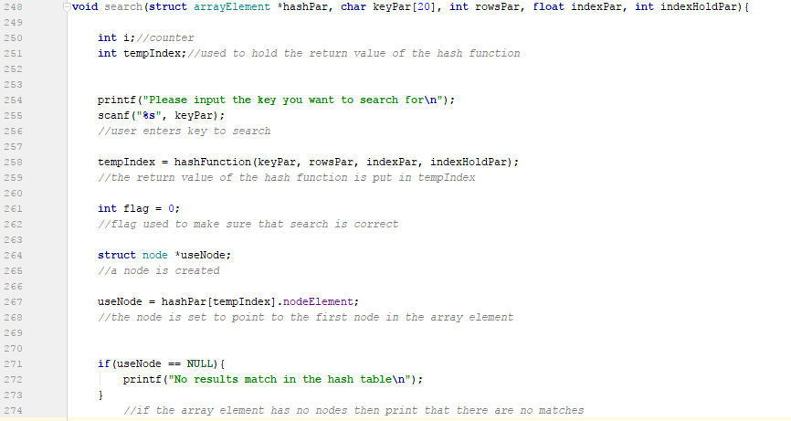

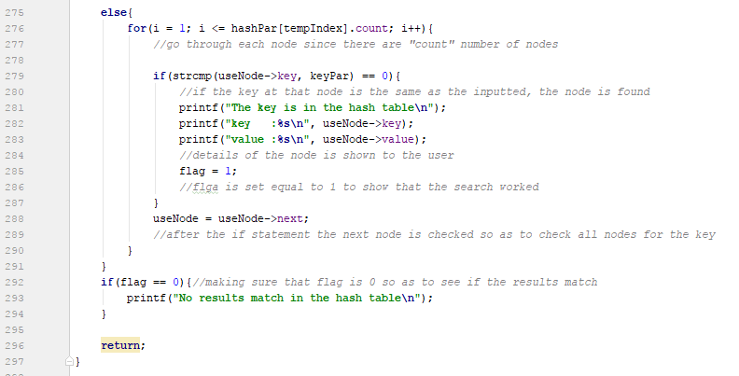
Figure 30: Search function part 1

Figure 31:search function part 2
The function here prompts the user to enter the key, after entering the key, the index of the key is obtained and stored in the variable tempIndex. A flag is created and set to 0.A new node is created which points to the first element of the index row. The node is tested to see if it equal to null, if so then the index contains no nodes and no key can be in that index. If the new node is not equal to null then a for loop is used to go through each node in the linked list of the index with the same method used in the showAll() function. However, with each iteration the key pointed to by the node is tested to see if it is equal to the inputted key and if so then the key being searched for is in the hash table and the corresponding value is also printed. The flag created is set to 1 to show that search is completed. The flag is tested to make sure the search occurred, if not then no key would match in the hash table.

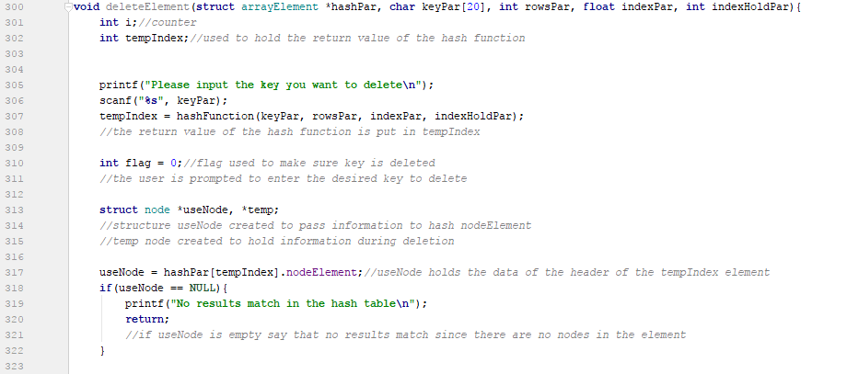

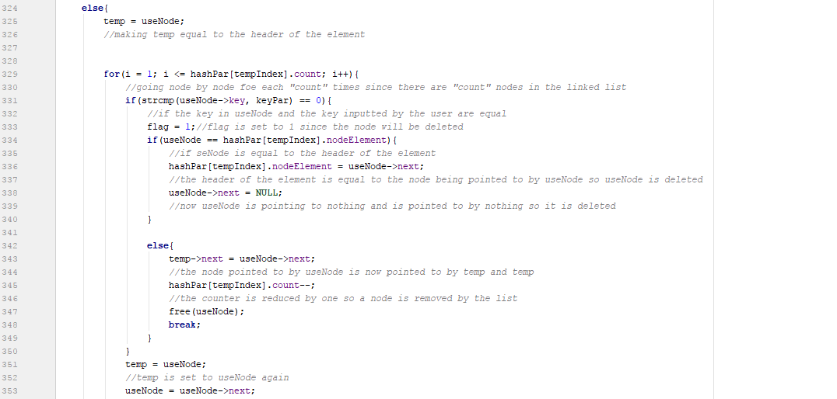
Figure 32: Delete function part 1

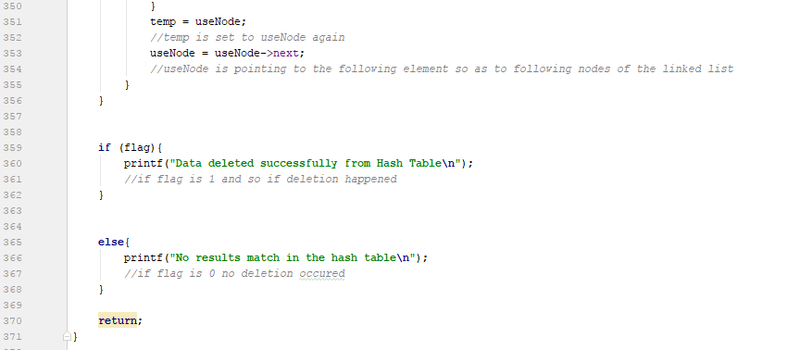
Figure 33: Delete function part 2

Figure 34: Delete function part 3
This is the delete function. The user here first enters the key the user wants to delete and an index value of the hash table is obtained. Two nodes are created, useNode is set to point to header node. If the new node is null then there are no keys in that index. However, if there the new node is not null, the other new node temp is set to point to the header of the index and a for loop is created to iterate the linked list at an index. If during iteration a node in the linked list has the same key as the one given by the user then the flag is set to 1 and it is checked whether or not the node is the header node, if the header node contains the key then set the header node equal to the node pointed to by the new node newNode. The new node is then set to point to null. However, if the key is not the header then a different approach is needed. The next node after temp is set equal to the next node after the new node newNode. After this temp is then set equal to newNode and newNode is set to the following node as another iteration will take place. The flag is checked finally and output is given whether it is 1 or 0 depending on if the deletion happened or not.

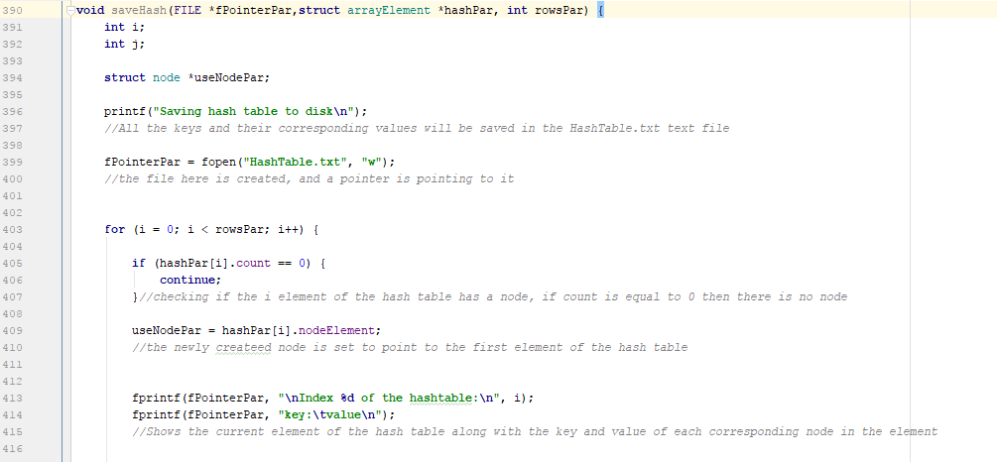
Figure 35: Save function part 1

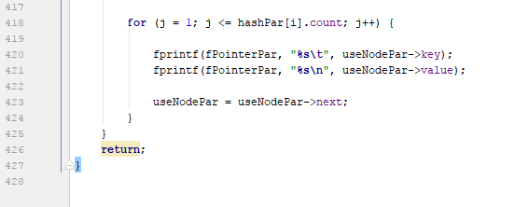
Figure 36: Save fucntion part 2

This function saves all the keys and values inputted by the user to a text file. A file pointer is used to open a file to write. Using the same method used in showAll() all the keys and values are printed into a text file which can be viewed after the program is ended.

The load and hashFunction function are relatively the same compared to the other similar functions of the other hash tables.

Output listings

"C:\Users\Owner\Dropbox\Uni\Programming principles in C-CPS1011\untitled2\cmake-build-debug\untitled2.exe"
Enter the number of elements inisde the hashtable
2
2
Menu
1. add
2. delete
3. search
4. show all
5. load
6. save
7. exit

input the function you want to do
1
1
Enter the key you want to input
Mikhail
Mikhail
Enter the corresponding value of the key
Cassar
Cassar
The index is 1
First element of the index is Mikhail
This is node number 1 of element 1 in the hash table
Menu
1. add
2. delete
3. search
4. show all
5. load
6. save
7. exit

input the function you want to do
1
1
Enter the key you want to input
Emily
Emily
Enter the corresponding value of the key
Mifsud
Mifsud
The index is 0
First element of the index is Emily
This is node number 1 of element 0 in the hash table
Menu
1. add
2. delete
3. search
4. show all
5. load
6. save
7. exit

input the function you want to do
4
4

Index 0 of the hashtable:
key: value
Emily Mifsud

Index 1 of the hashtable:
key: value
Mikhail Cassar
Menu
1. add
2. delete
3. search
4. show all
5. load
6. save
7. exit

input the function you want to do
2
2
Please input the key you want to delete
Mikhail
Mikhail
The index is 1
Data deleted successfully from Hash Table
Menu
1. add
2. delete
3. search
4. show all
5. load
6. save
7. exit

input the function you want to do
1
1
Enter the key you want to input
Edward
Edward
Enter the corresponding value of the key
Scibberas
Scibberas
The index is 1
First element of the index is Edward
This is node number 1 of element 1 in the hash table
Menu
1. add
2. delete
3. search
4. show all
5. load
6. save
7. exit

input the function you want to do
4
4

Index 0 of the hashtable:
key: value
Emily Mifsud

Index 1 of the hashtable:
key: value
Edward Scibberas
Menu
1. add
2. delete
3. search
4. show all
5. load
6. save
7. exit

input the function you want to do
6
6
Saving hash table to disk
Menu
1. add
2. delete
3. search
4. show all
5. load
6. save
7. exit

input the function you want to do
7
7
End of program

HashTable.txt:
Index 0 of the hashtable:
key: value
Emily Mifsud
Index 1 of the hashtable:
key: value
Edward Scibberas

Task 2d

Problem Definition
Provide a single test driver program (no user input is required) to
test all versions of the hash table. All versions must be compiled
as shared libraries implementing the ‘same’ Abstract Data Type
(ADT) API as exposed by a single header (.h) file.

Code fragments
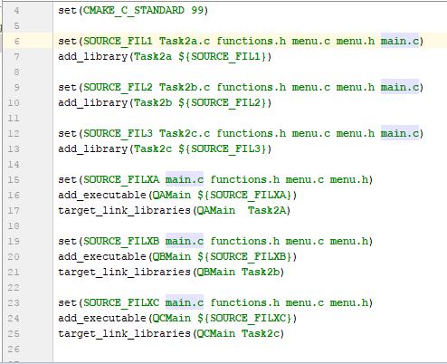
Figure 37: Cmake text file contains the shared library

This is the cmake file which was needed to make the shared library between the three hash tables.

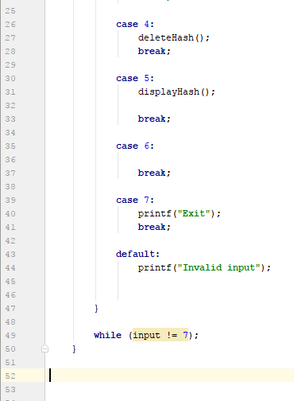

Figure 2: .h file part 1

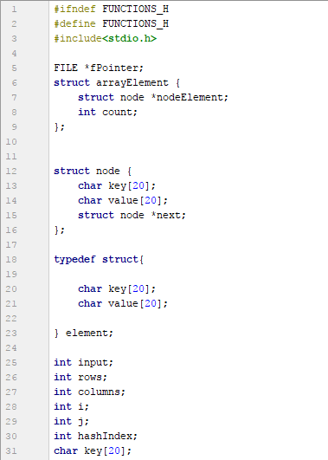
Figure 38: .h file part 1

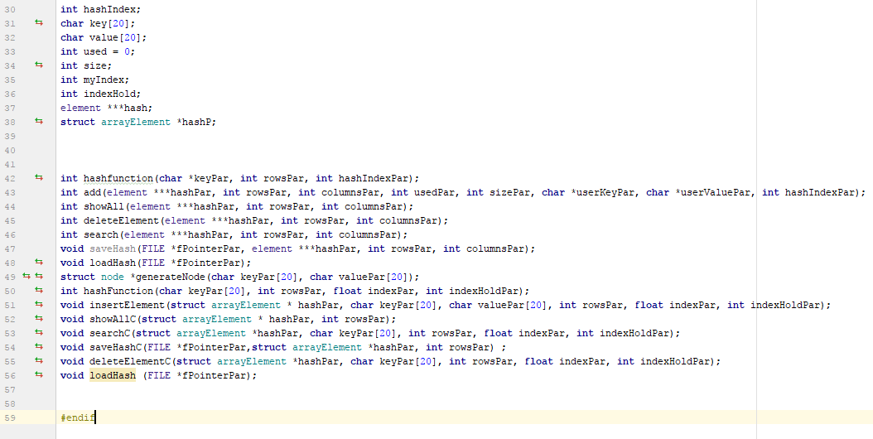
Figure 39: .h file part 2

This file is the .h file which contains all the functions of the three hash tables and so all the hash tables need this in order to act as an abstract data type
Figure 4: The driver program

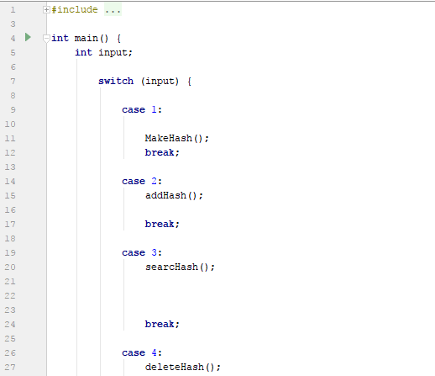

Figure 40: driver program

This is the main, this will act as the test driving program of the project

